Homework 2
- Simple Trouble Shooting
An open device always has zero current and unknown voltage. The voltage present across the open terminals is determined by inspecting the rest of the circuit. On the other hand, a shorted device always has the zero voltage and unknown current. The current flowing through the shorted device is determined by inspecting the rest of the circuit.
- Analyze the following circuit and simulate it on Multisim:
Insert your Multisim circuit schematic image here with VA and VB showing. (5)
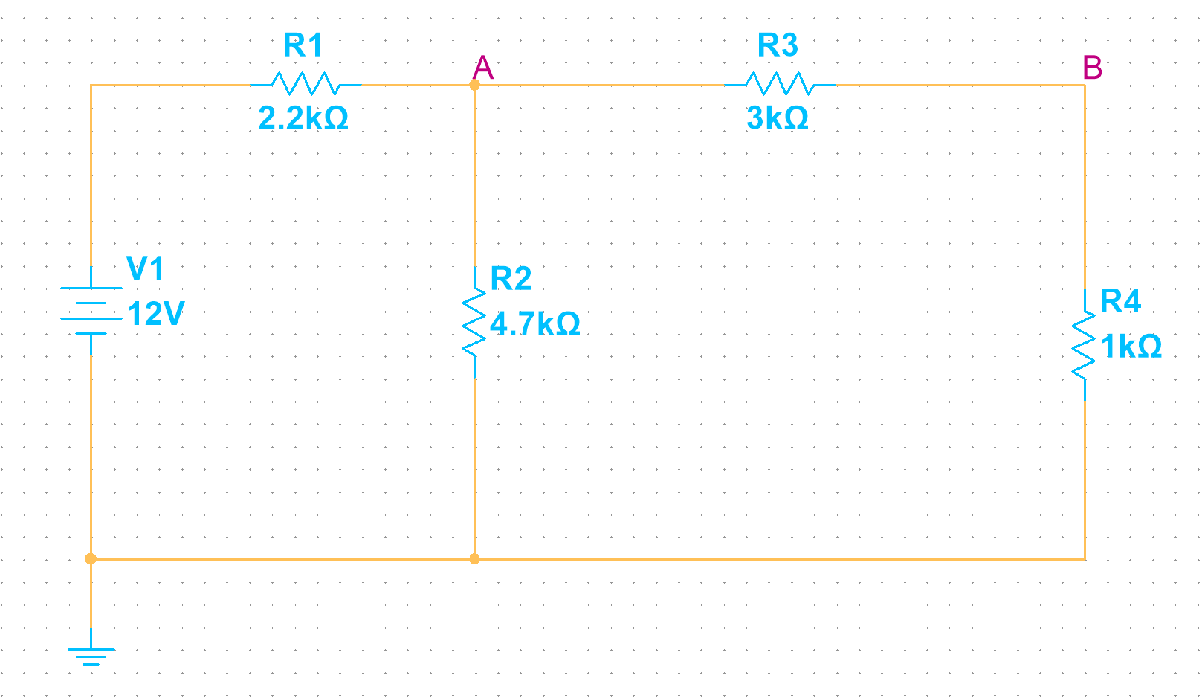

- Troubles and voltages (10):
Show your work for R3 open (5):

Show your work for R3 shorted (5):
 | Calculated  (keep 4 significant figures) |  | Measured
 |  |  | Multisim
Trouble | VA | VB | VA | VB
circuit OK
R1 Open
R2 Open
R3 Open
R4 Open
R1 Shorted
R2 Shorted
R3 Shorted
R4 Shorted
- Thevenin’s Theorem
- Calculate $R_{th}$ and $V_{th}$ of the circuit below.
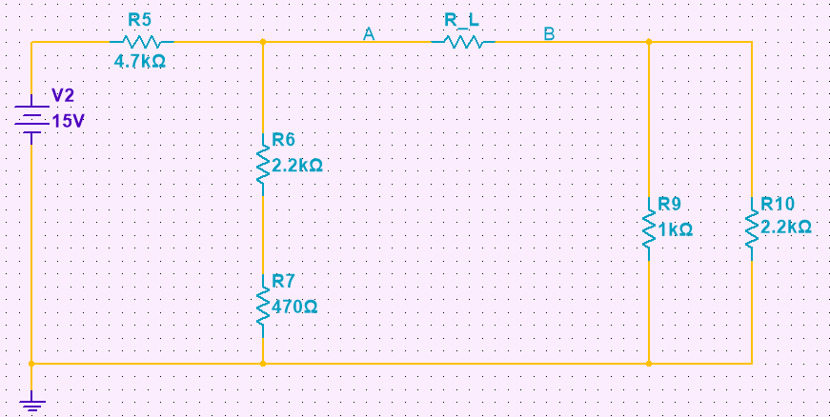
Show your work here. (10)

Thevenin Values:
Calculated
Rth
Vth

- Simulate your Thevenin equivalent circuits with Multisim. Calculate the load voltage $V_{L}$ with a 1kΩ and a 4.7kΩ resistor.
Insert your Multisim circuit schematic image with a 1 kΩ load here. (5)

Insert your Multisim circuit schematic image with a 4.7 kΩ load here. (5)

Results (5)
Loaded Voltages
 | Calculated VL | Multisim VL
1 kΩ
4.7 kΩ

- Impedance Match
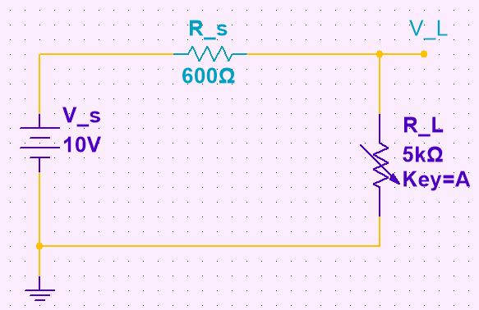
$R_{s}$ is the output impedance of our source $V_{s}$. $V_{L}$ is the output voltage of a variable resistor $R_{L}$.

- Derive the formula of output power $P_{L}$, and prove $P_{L_max}$ happens when $R_{L}=R_{s}$.
Show your work (5)

- Plot output power $P_{L}$ as a function of $\frac{R_{L}}{R_{S}}$ , $R_{L}$ varies from 0Ω to 5kΩ with a step size of 100Ω.

(5)
- We learned $V_{L}$ as a function of $R_{L}$ , $R_{s}$and $V_{s}$. Normally we know $V_{s}$ which is the open source voltage of a voltage source. We could easily measure $R_{L}$ and $V_{L}$ using a DMM. Write done $R_{L}$ as a linear function of $R_{s}$.
(5) show your work:

- If $R_{s}$ is unknown. How can we use a variable resistor $R_{L}$ and DMM to measure the output impedance?
(5) show your work:

